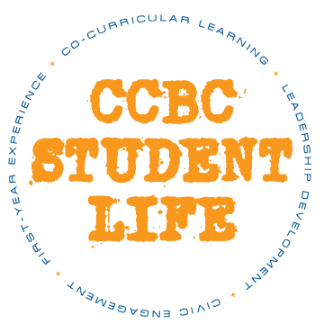

**CCBC STUDENT LIFE**

**Student Leadership Request for Reinstatement**

Complete and submit the following items for consideration:

* Student Information
* Returner Questions

Please indicate your leadership program:

_Y_ **Ambassador Program**

____ **First-Year Experience (FYE) Mentor Program**

____ **Student Government Association (SGA)**

**Student Information**

Last Name: Dada First Name: Opeyemi

Student ID: 901109027 Primary CCBC Campus: Catonsville

Email: opeyemiyankee@gmail.com Preferred Phone #: 4436751937

Major: Information technology GPA: 2.16

Mailing Address: 4360 breeders cup circle

Number of Semesters at CCBC: 4 Anticipated Graduation Date: December 20 2023

Shirt Size: Large Semester for Reinstatement: five

**Returner Questions**

1. Describe your experiences during your time away from the program.

* I had a wonderful time collaborating with my fellow ambassadors and leaders. it gave me the opportunity to be bold and conquer my fear of interacting with people on campus.

1. Were you involved/active in any clubs, organizations, or campus activities during the semester?

If so, please describe your level of involvement.

* Yes I was involved in track and field, my level of involvement was high it becomes one of the central component of my life.

1. If you were to return to the program, what role do you see yourself taking within the group?

* Given my capabilities in natural language (Yoruba and broken English) processing and understanding, I could assist in communication and information sharing between members of the group who may speak different languages or have trouble expressing themselves. I could also help with research and provide insights and data analysis to support the group's goals and initiatives. Additionally, I could act as a mediator in case of conflicts or misunderstandings within the group, using my language processing abilities to help find common ground and foster constructive dialogue.